Student Id – IT24610811

Name – Abishakar.G

Lab sheet 10

1

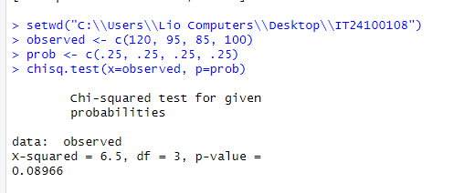

2

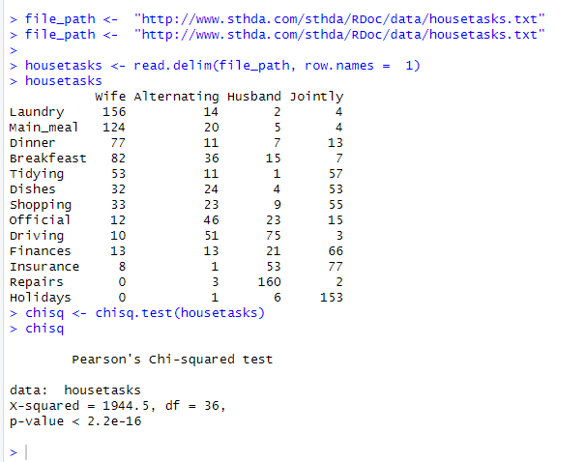

3

